Jubilee 3D Documentation (Part 2)
Prepared by: Arthur Chong
Date: 05/20/2025
This document is the second part of a multi-part guide that provides step-by-step instructions on how to connect a Jubilee 3D printer using G-Code and Jupyter Notebook.

Jubilee 3D Documentation (Part 2) 1
Connecting Jubilee via G-Code 2
1. Accessing the G-Code Web Interface 2
2. Key Interface Components (Figure Description) 3
3. Side Menu – File Options Overview (Additional Information) 4
Automating Jubilee with Jupyter Notebook 9
1. Getting Started Resources 9
2. API Reference 9

Connecting Jubilee via G-Code
Once the IP address has been successfully configured for the Jubilee, you can connect to it via a web interface that allows G-Code control.

1. Accessing the G-Code Web Interface
- Launch your preferred browser (e.g., Google Chrome). The IP address assigned to Jubilee during setup should be saved in your browser history or bookmarks.
- Type in the IP address you assigned to the Jubilee during setup.
- You will be directed to the Duet Web Control interface.
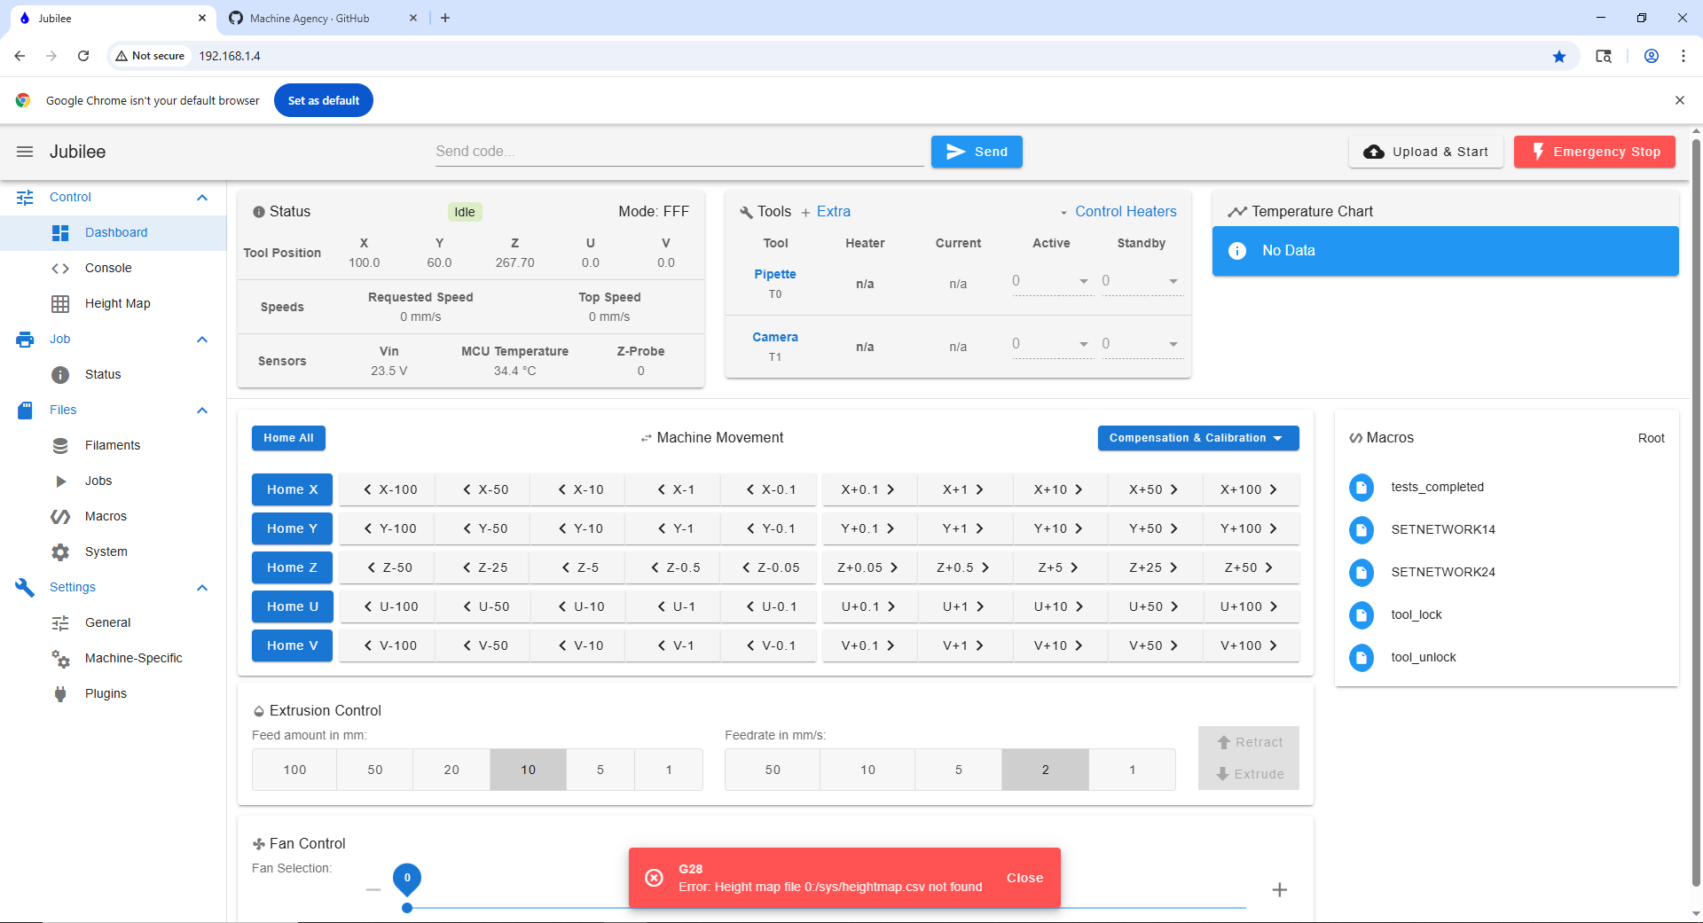
a
b
c
d
This interface allows you to send G-Code commands directly to the printer, monitor status, control temperatures, move motors, and more.

Getting Started Safely
- Turn on the Jubilee:
Use the external power switch located on the side of the Jubilee frame. (Picture of the switch)

- Home the Axes:
Before moving the robotic platform, always click "Home All" in the Duet interface to home the X, Y, Z, and U axes.
(U will home first, Y , x , and z)

- Manual Control:
After homing, you may freely move any of the axes using the interface sliders or input boxes based on your needs.
(Keep in mind of the homing axis)

- Emergency Stop:
In case of an unexpected issue or malfunction, click the red "Emergency Stop" button in the top-right corner of the screen.
⚠️ This will immediately halt all motion and processes.
u

2. Key Interface Components (Figure Description)
- Side Menu: Access core sections including Jobs, G-Code Files, Machine Control, and Settings.
- G-Code Console: Send manual commands to operate the printer or test routines.
- Machine Status Panel: View real-time temperature readings, current axis positions, feed rates, and job status.
- Motion Control Panel: Move the bed plate and tool holder by manually changing the X, Y, Z, and U axis positions.

3. Side Menu – File Options Overview (Additional Information)
Within the side menu of the Duet Web Control interface, the "Files" section is divided into several important tabs:

1. Jobs
- Contains G-code files that can be executed as print or automation jobs.
- You can upload, delete, or organize files for direct execution on the machine.

- Pre-made Job Templates
Science Jubilee provides a collection of pre-configured G-code templates used for:
  - Tool pickup
  - Tool change
These templates are useful starting points for setting up your own automated workflows.
👉 Science Jubilee G-code Templates (GitHub)

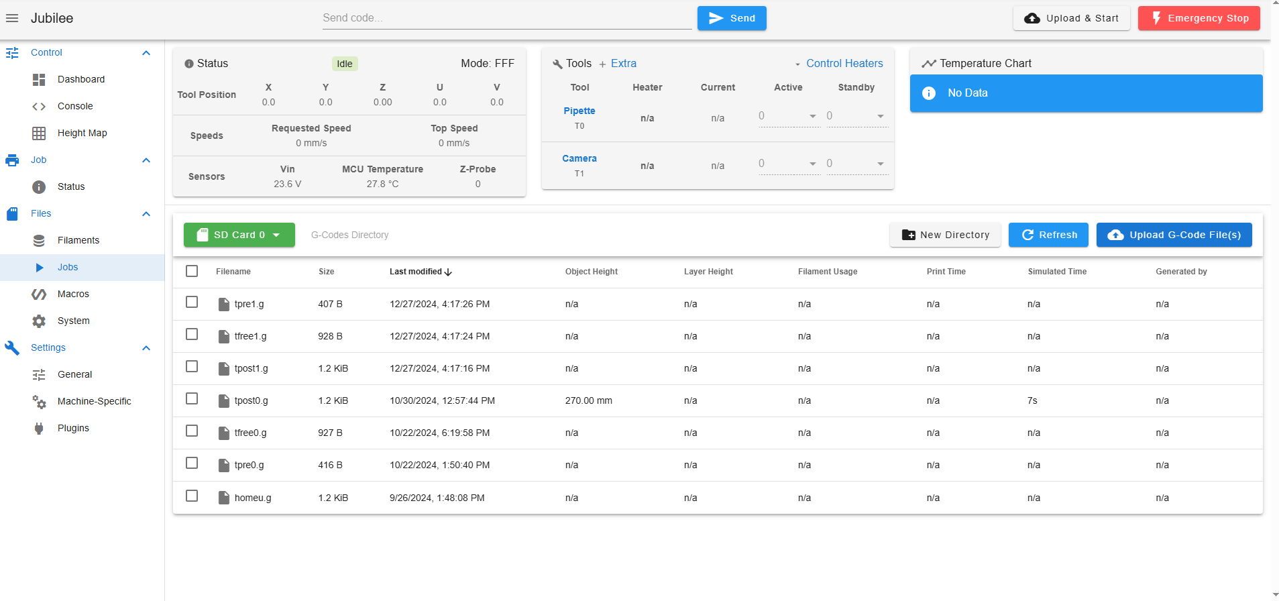

2. Macros
- Stores reusable G-code scripts for common tasks (e.g., tool lock, tool unlocking).
- Useful for automating frequent commands or procedures.

- Pre-configured Macro Files
The Machine Agency has provided a collection of. g macro files specifically designed for Jubilee with Duet 3.
👉 Duet3 Macros – Jubilee GitHub Repository

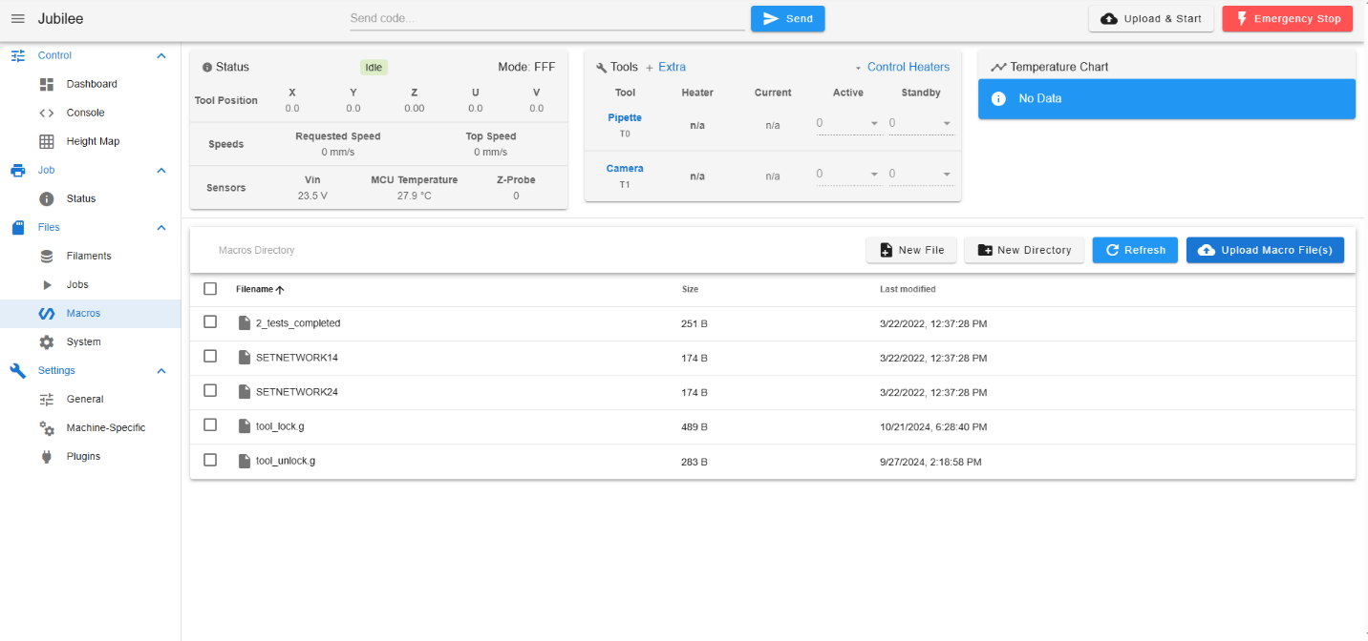

3. System
- Holds configuration files such as:
  - config.g (main printer configuration)
  - Homex.g, homey.g, homez.g, etc. – Homing sequences for each axis.
- Changes to these files affect machine behavior and should be edited carefully based on your system.
⚠️ Note: Any changes to these files directly affect how the Jubilee operates. Be sure to back up the original files and test carefully after making modifications.

- Reference Configuration Files
The Machine Agency provides a complete set of example configuration files for a Duet 3-based Jubilee setup. These can be used as a baseline and tailored to your lab’s hardware.
👉 System Config Files – Duet3 (Jubilee GitHub)
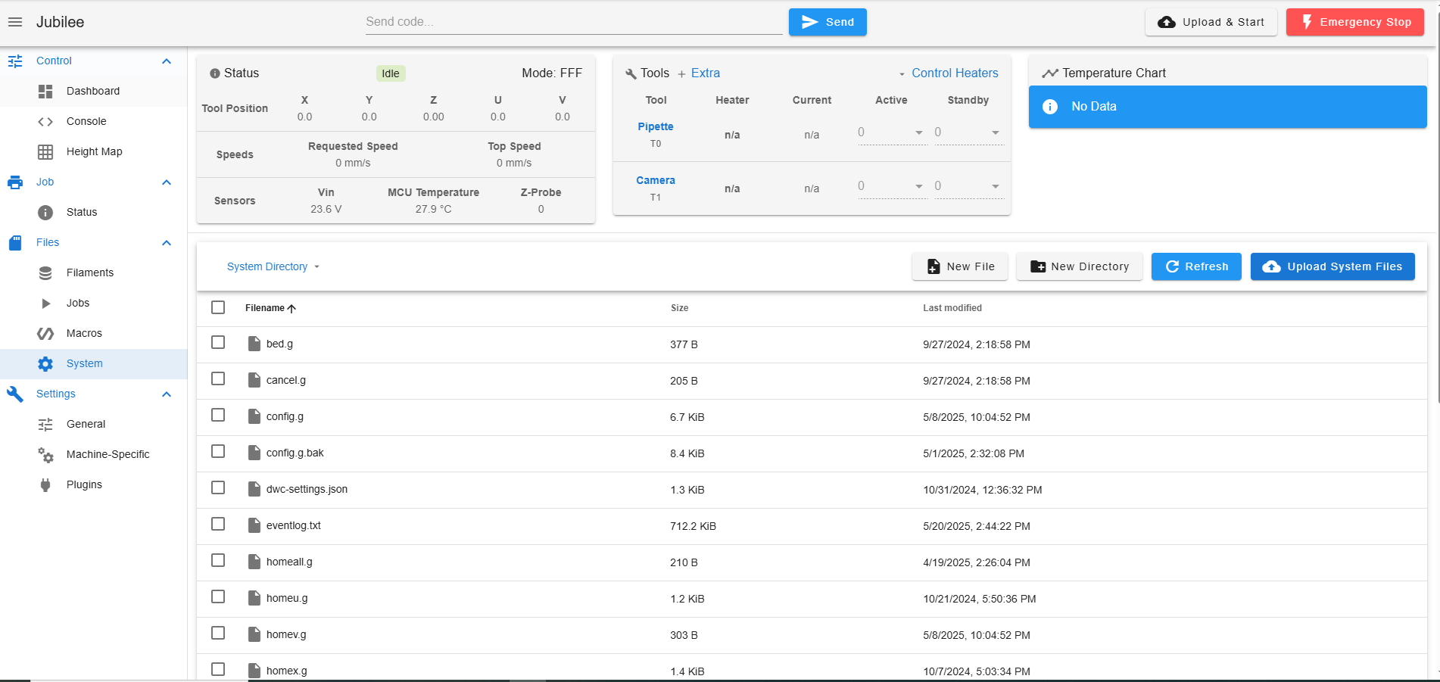

4. Machine-Specific
- Displays information specific to the hardware setup.
- Here you can view:
  - The type of Duet board in use (e.g., Duet 3 Mini, Duet 2 WiFi)
  - Firmware version and connected expansion boards
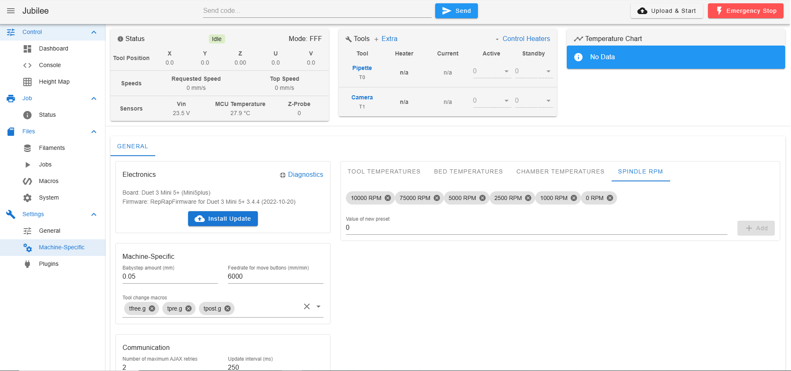

📚 Additional Resources
To learn more about G-Code and how it's used in Jubilee, refer to the following documentation:
🔗 G-Code Primer
👉 https://science-jubilee.readthedocs.io/en/latest/getting_started/primer.html
For provisioning the board and initial connection setup:
🔗 New User Guide
👉 https://science-jubilee.readthedocs.io/en/latest/getting_started/new_user_guide.html
Duet3D also provides an excellent guide on connecting to your Duet board:
🔗 Duet3D – Getting Connected
👉 https://docs.duet3d.com/How_to_guides/Getting_connected/Getting_connected_to_your_Duet

Senbd code

Config gile change – tool manupulation

Automating Jubilee with Jupyter Notebook
After uploading all the necessary files into the Macros and System folders, users can connect to Jubilee programmatically using Jupyter Notebooks. This enables full automation of experiments and workflows.
Through Jupyter, users can:
- Send G-code commands via Python
- Control tool pickup and change sequences
- Coordinate movement and actions on the Lab Automation Deck
- Run complex experimental protocols with real-time feedback

1. Getting Started Resources
To begin using Jubilee with Jupyter Notebooks, refer to the following tutorials:
- 👉 Intro to the Machine Driver
Learn about the software stack behind Jubilee automation.
- 👉 Lab Automation Deck Guide
Understand how the deck is structured and how to control lab hardware in a programmable way.

2. API Reference
The Science Jubilee project provides a fully documented API that outlines the available functions and classes used to interact with and automate the Jubilee 3D printer.
Official API Documentation:
👉 Science Jubilee AutoAPI Reference

